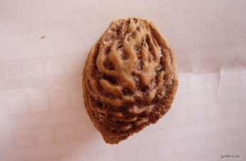

|  |  |  |  |  |
| --- | --- | --- | --- | --- |
|  |  |  |  |  |

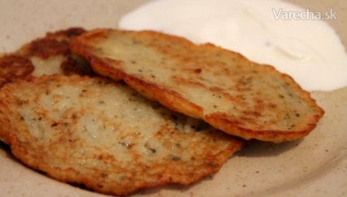

|  |  |  |  |  |  |
| --- | --- | --- | --- | --- | --- |
|  |  |  |  |  |  |

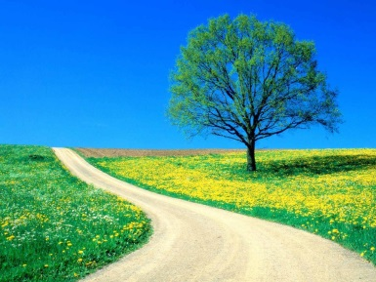

|  |  |  |  |  |
| --- | --- | --- | --- | --- |
|  |  |  |  |  |

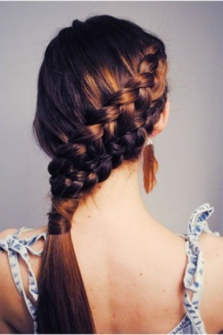

|  |  |  |  |  |  |  |
| --- | --- | --- | --- | --- | --- | --- |
|  |  |  |  |  |  |  |



|  |  |  |  |  |
| --- | --- | --- | --- | --- |
|  |  |  |  |  |



|  |  |  |  |  |  |
| --- | --- | --- | --- | --- | --- |
|  |  |  |  |  |  |



|  |  |  |  |  |
| --- | --- | --- | --- | --- |
|  |  |  |  |  |



|  |  |  |  |  |  |  |
| --- | --- | --- | --- | --- | --- | --- |
|  |  |  |  |  |  |  |

|  |  |  |  |  |
| --- | --- | --- | --- | --- |
|  |  |  |  | Packa, Ko&ccaron;ka, Tlapa, Ko&ccaron;i&ccaron;í Tlapka, M&ecaron;kký, Tlapa Tisk |

|  |  |  |  |  |  |  |
| --- | --- | --- | --- | --- | --- | --- |
|  |  |  |  |  |  | Výsledek obrázku pro originální cukroví |

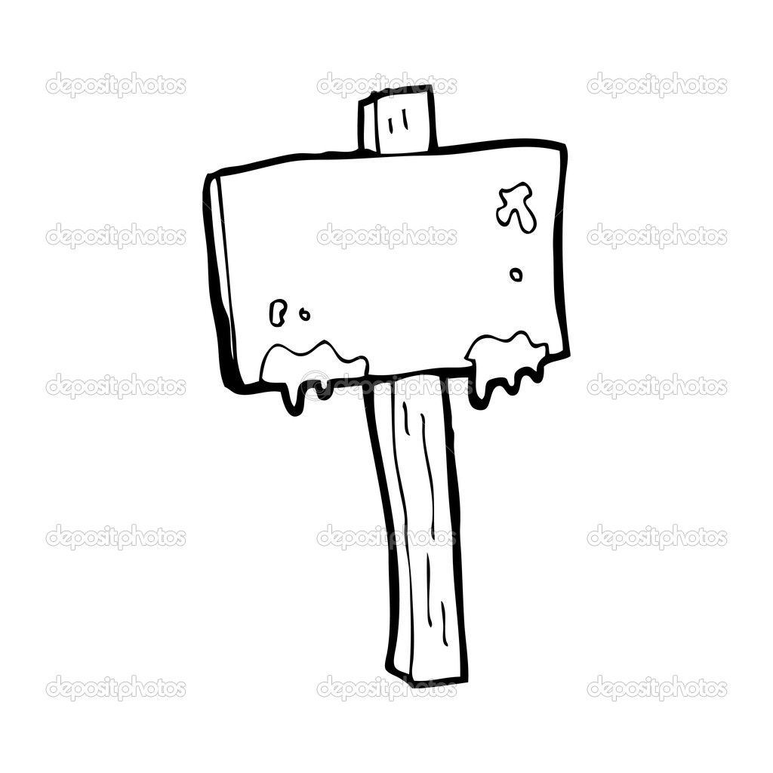

|  |  |  |  |  |  |
| --- | --- | --- | --- | --- | --- |
|  |  |  |  |  |  |

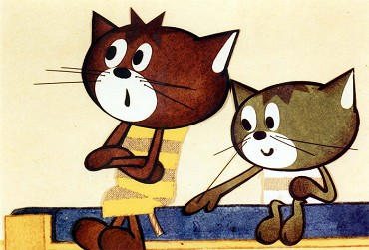

|  |  |  |  |  |  |  |  |
| --- | --- | --- | --- | --- | --- | --- | --- |
|  |  |  |  |  |  |  |  |

|  |  |  |  |  |
| --- | --- | --- | --- | --- |
|  |  |  |  | Packa, Ko&ccaron;ka, Tlapa, Ko&ccaron;i&ccaron;í Tlapka, M&ecaron;kký, Tlapa Tisk |

|  |  |  |  |  |  |  |
| --- | --- | --- | --- | --- | --- | --- |
|  |  |  |  |  |  | Výsledek obrázku pro originální cukroví |



|  |  |  |  |  |  |
| --- | --- | --- | --- | --- | --- |
|  |  |  |  |  |  |



|  |  |  |  |  |  |  |  |
| --- | --- | --- | --- | --- | --- | --- | --- |
|  |  |  |  |  |  |  |  |