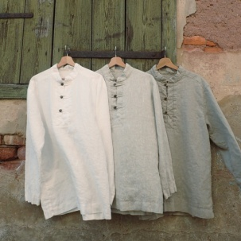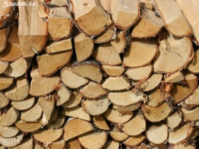 **Spoj k sobě přírodninu a výrobek.**

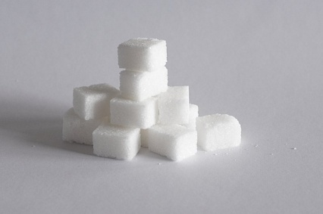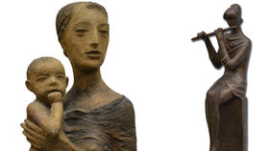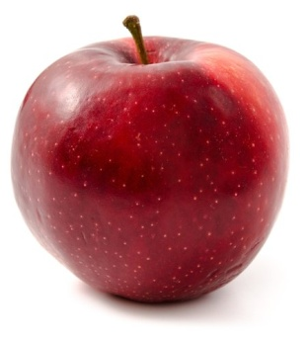

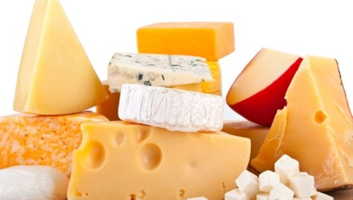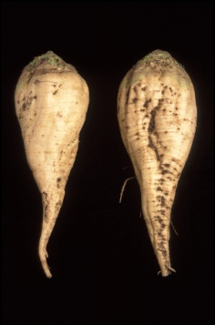

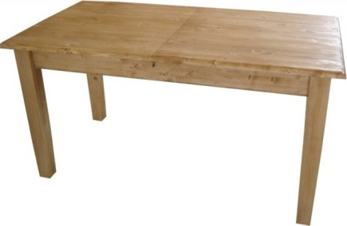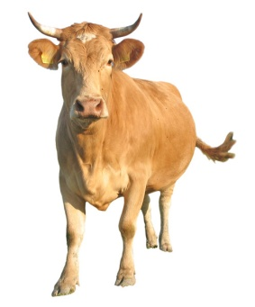

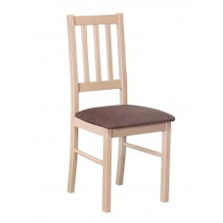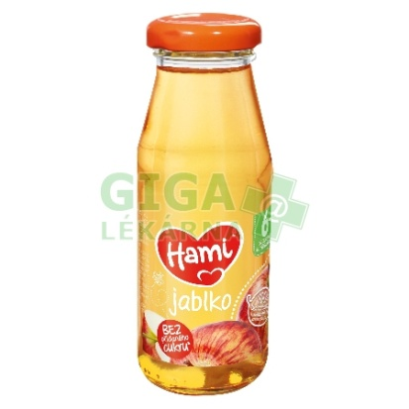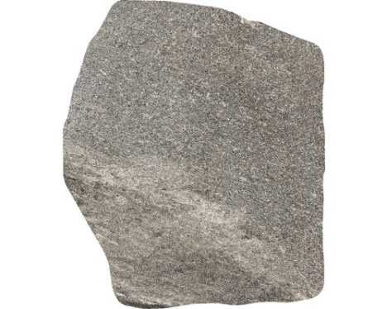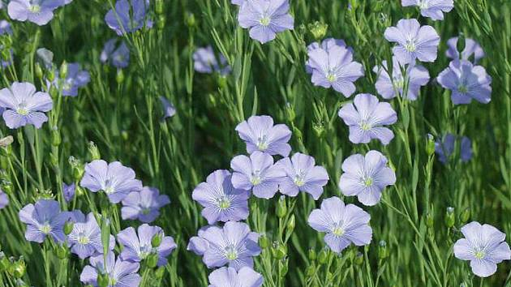

|  |  |  |  |  |
| --- | --- | --- | --- | --- |
| **DĚ** | **TĚ** | **NĚ** | **BĚ** | **PĚ** |
|  |  |  |  |  |
|  |  |  |  |  |
|  |  |  |  |  |
|  |  |  |  |  |
|  |  |  |  |  |
|  |  |  |  |  |
|  |  |  |  |  |
|  |  |  |  |  |
|  |  |  |  |  |

**Vymýšlej slova s danou slabikou.**